 | train_acc | test_acc | test_precision | test_recall | test_f1
depth
1 | 0.7615 | 0.7167 | 0.6000 | 0.3158 | 0.4138
2 | 0.7615 | 0.7000 | 0.5217 | 0.6316 | 0.5714
3 | 0.7992 | 0.7667 | 0.6000 | 0.7895 | 0.6818
4 | 0.8285 | 0.7500 | 0.5909 | 0.6842 | 0.6341
5 | 0.8410 | 0.6667 | 0.4783 | 0.5789 | 0.5238
6 | 0.8745 | 0.7167 | 0.5455 | 0.6316 | 0.5854
7 | 0.9247 | 0.7000 | 0.5238 | 0.5789 | 0.5500
8 | 0.9289 | 0.6833 | 0.5000 | 0.5789 | 0.5366
9 | 0.9540 | 0.6833 | 0.5000 | 0.4737 | 0.4865
10 | 0.9582 | 0.6833 | 0.5000 | 0.5263 | 0.5128
11 | 0.9707 | 0.7167 | 0.5500 | 0.5789 | 0.5641
12 | 0.9749 | 0.7333 | 0.5714 | 0.6316 | 0.6000
13 | 0.9916 | 0.7167 | 0.5500 | 0.5789 | 0.5641
14 | 0.9958 | 0.7333 | 0.5714 | 0.6316 | 0.6000
15 | 1.0000 | 0.7333 | 0.5714 | 0.6316 | 0.6000
Best depth by test accuracy: 3 | Test accuracy = 0.7667
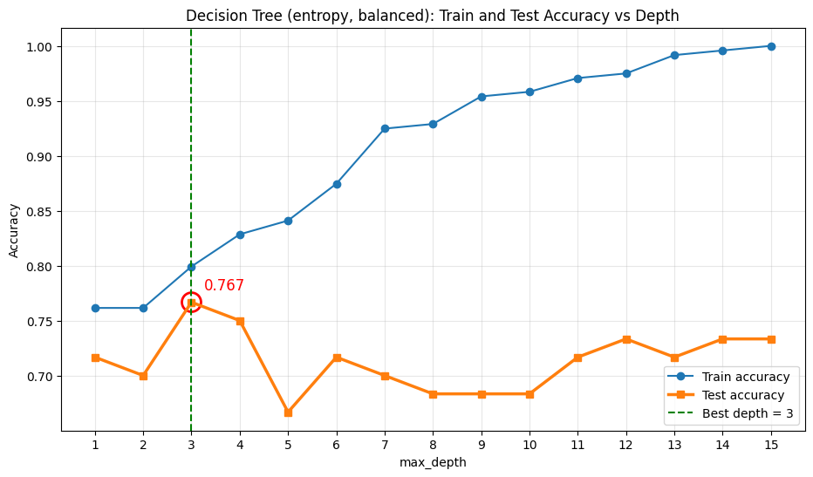
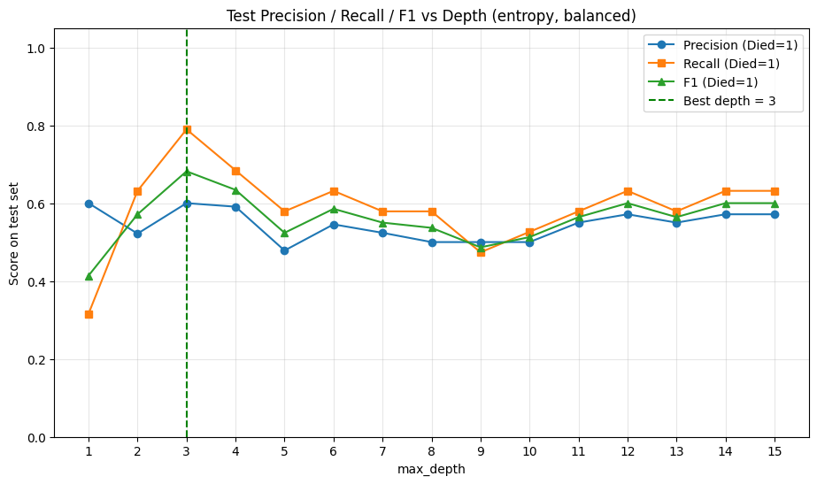

 | Best depth (3) | Full tree
serum_creatinine | 0.5264 | 0.2440
ejection_fraction | 0.3197 | 0.1254
age | 0.1538 | 0.1958
creatinine_phosphokinase | 0.0000 | 0.1273
anaemia | 0.0000 | 0.0000
high_blood_pressure | 0.0000 | 0.0121
diabetes | 0.0000 | 0.0288
platelets | 0.0000 | 0.1389
serum_sodium | 0.0000 | 0.0655
sex | 0.0000 | 0.0229
smoking | 0.0000 | 0.0393
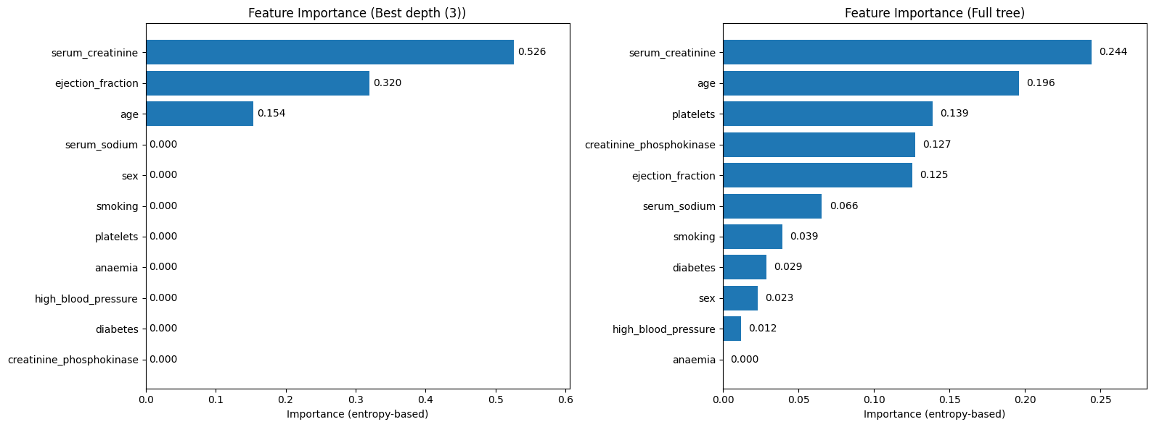

=== Metrics Summary ===
 | Train | Test
Accuracy | 0.7992 | 0.7667
Precision (Died=1) | 0.6526 | 0.6000
Recall (Died=1) | 0.8052 | 0.7895
F1-score (Died=1) | 0.7209 | 0.6818
=== Classification Report (Test) ===
 | precision | recall | f1-score | support
Survived (0) | 0.8857 | 0.7561 | 0.8158 | 41.0000
Died (1) | 0.6000 | 0.7895 | 0.6818 | 19.0000
accuracy | 0.7667 | 0.7667 | 0.7667 | 0.7667
macro avg | 0.7429 | 0.7728 | 0.7488 | 60.0000
weighted avg | 0.7952 | 0.7667 | 0.7734 | 60.0000
=== Confusion Matrix (Test) ===
 | Predicted: Survived | Predicted: Died
Actual: Survived | 31 | 10
Actual: Died | 4 | 15
